3-11-16

1.] Tables r not being created but executing

Sol- check if u hv added @Entity

@Table(name="product") in model(i.e product.java)

2.] WARNING: Exception encountered during context initialization - cancelling refresh attempt: org.springframework.beans.factory.BeanCreationException: Error creating bean with name 'sessionfactory' defined in com.niit.shopping.config.ApplicationContextConfig: Bean instantiation via factory method failed; nested exception is org.springframework.beans.BeanInstantiationException: Failed to instantiate [org.hibernate.SessionFactory]: Factory method 'getSessionFactory' threw exception; nested exception is org.hibernate.AnnotationException: No identifier specified for entity: com.niit.shopping.model.Category

Exception in thread "main" org.springframework.beans.factory.BeanCreationException: Error creating bean with name 'sessionfactory' defined in com.niit.shopping.config.ApplicationContextConfig: Bean instantiation via factory method failed; nested exception is org.springframework.beans.BeanInstantiationException: Failed to instantiate [org.hibernate.SessionFactory]: Factory method 'getSessionFactory' threw exception; nested exception is org.hibernate.AnnotationException: No identifier specified for entity: com.niit.shopping.model.Category

Sol- 1st close ur eclipse ide and then maven build. Once ,clean project and run

3.]

Exception in thread "main" org.springframework.beans.factory.NoSuchBeanDefinitionException: No bean named 'supplier' is defined

S0l:]add annotated class and @autowired,@bean related to that class

4:] Nov 03, 2016 5:14:54 PM org.springframework.context.annotation.AnnotationConfigApplicationContext prepareRefresh

INFO: Refreshing org.springframework.context.annotation.AnnotationConfigApplicationContext@533ddba: startup date [Thu Nov 03 17:14:54 PDT 2016]; root of context hierarchy

Nov 03, 2016 5:14:55 PM org.springframework.beans.factory.annotation.AutowiredAnnotationBeanPostProcessor <init>

INFO: JSR-330 'javax.inject.Inject' annotation found and supported for autowiring

data source

Nov 03, 2016 5:14:55 PM org.hibernate.Version logVersion

INFO: HHH000412: Hibernate Core {5.2.3.Final}

Nov 03, 2016 5:14:55 PM org.hibernate.cfg.Environment <clinit>

INFO: HHH000206: hibernate.properties not found

Nov 03, 2016 5:14:55 PM org.hibernate.cfg.Environment buildBytecodeProvider

INFO: HHH000021: Bytecode provider name : javassist

hbernate properties

session factory

Nov 03, 2016 5:14:55 PM org.hibernate.annotations.common.reflection.java.JavaReflectionManager <clinit>

INFO: HCANN000001: Hibernate Commons Annotations {5.0.1.Final}

Nov 03, 2016 5:14:55 PM org.hibernate.dialect.Dialect <init>

INFO: HHH000400: Using dialect: org.hibernate.dialect.H2Dialect

transaction

user dao

user

product dao

product

category dao

category

supplier dao

supplier

supplier created test

4-11-16

5.] Exception in thread "main" org.springframework.transaction.CannotCreateTransactionException: Could not open Hibernate Session for transaction; nested exception is java.lang.NoClassDefFoundError: org/hibernate/engine/transaction/spi/TransactionContext

at org.springframework.orm.hibernate4.HibernateTransactionManager.doBegin(HibernateTransactionManager.java:544)

sol:-comment @tansaction ,repository,enabletransaction…

6.] org.hibernate.HibernateException: save is not valid without active transaction

Sol:Use this Session s=sessionFactory.getCurrentSession(); Transaction

t=s.beginTransaction(); s.saveOrUpdate(category); t.commit();

but not----//sessionFactory.getCurrentSession().saveOrUpdate(category);

7.]

Exception encountered during context initialization - cancelling refresh attempt: org.springframework.beans.factory.UnsatisfiedDependencyException: Error creating bean with name 'adminHomeController': Unsatisfied dependency expressed through field 'productDAO'; nested exception is org.springframework.beans.factory.NoSuchBeanDefinitionException: No qualifying bean found for dependency [com.niit.shopping.dao.ProductDAO]: expected at least 1 bean which qualifies as autowire candidate. Dependency annotations: {@org.springframework.beans.factory.annotation.Autowired(required=true)}

Sol:-clean,compile

8.] Error creating bean with name 'homeController': Unsatisfied dependency expressed through field 'userDAO'; nested exception is org.springframework.beans.factory.NoSuchBeanDefinitionException: No qualifying bean found for dependency [com.suman.shopping.dao.UserDAO]: expected at least 1 bean which qualifies as autowire candidate. Dependency annotations: [{@org.springframework.beans.factory.annotation.Autowired(required=true)}](mailto:%7b@org.springframework.beans.factory.annotation.Autowired(required=true)%7d)

---No qualifying bean found for dependency [com.suman.shopping.dao.UserDAO]: expected at least 1 bean which qualifies as autowire candidate. Dependency annotations: [{@org.springframework.beans.factory.annotation.Autowired(required=true)}](mailto:%7b@org.springframework.beans.factory.annotation.Autowired(required=true)%7d)

Sol: check package they should be same for base-package:”com” componenet-scan:”com”

9.]

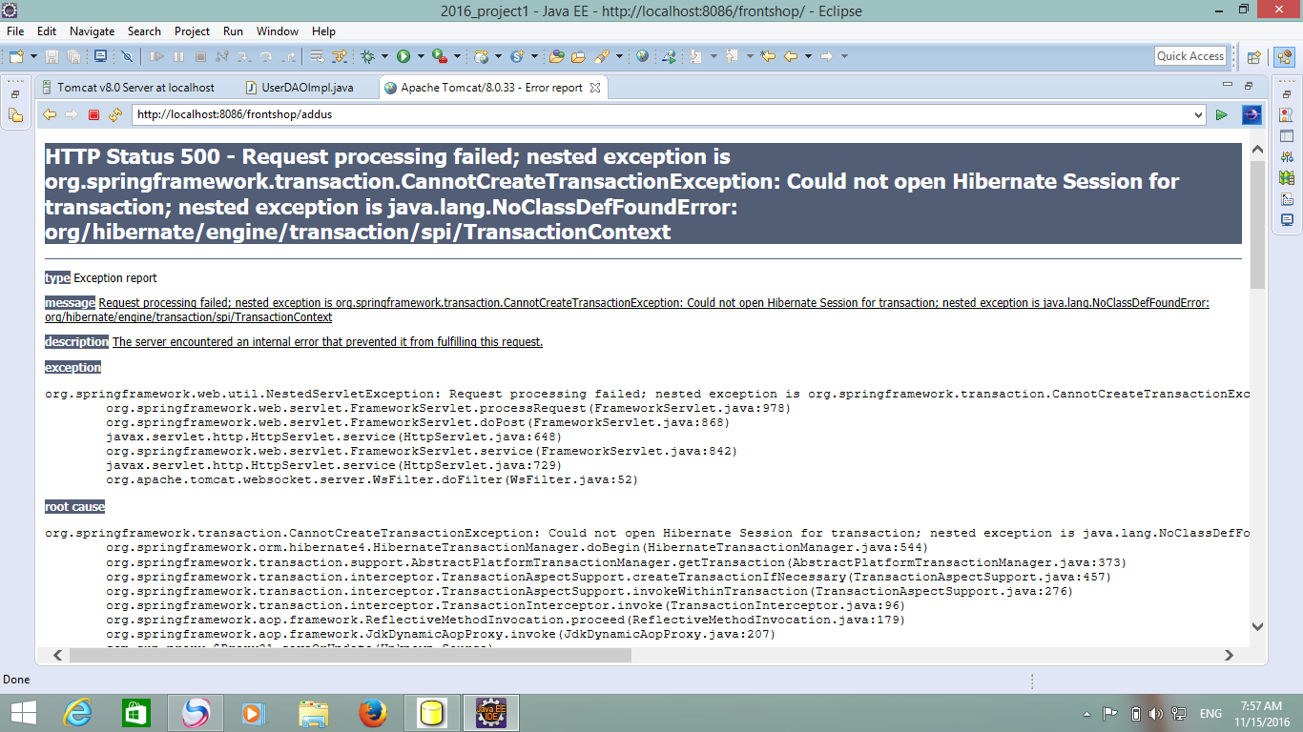

Check ur hibernate version

You use org.springframework.orm.hibernate4.HibernateTransactionManager for Hibernate 4. This class using TransactionContext from Hibernate 4.

Looks like you use Hibernate 5. Just change

import org.springframework.orm.hibernate4.HibernateTransactionManager;

import org.springframework.orm.hibernate4.LocalSessionFactoryBean;

to this

import org.springframework.orm.hibernate5.HibernateTransactionManager;

import org.springframework.orm.hibernate5.LocalSessionFactoryBean;

/*Session s = sessionFactory.getCurrentSession();

Transaction t = s.beginTransaction();

s.saveOrUpdate(user);

t.commit();

*/

and use this------sessionFactory.getCurrentSession().save(user);

10. Exception sending context destroyed event to listener instance of class org.springframework.web.context.ContextLoaderListener

java.lang.IllegalStateException: BeanFactory not initialized or already closed - call 'refresh' before accessing beans via the ApplicationContext

WARNING: Exception thrown from LifecycleProcessor on context close

java.lang.IllegalStateException: LifecycleProcessor not initialized - call 'refresh' before invoking lifecycle methods via the context: Root WebApplicationContext: startup date [Wed Nov 16 13:51:45 PST 2016]; root of context hierarchy

sol:Clean and compile

11.] Exception sending context initialized event to listener instance of class org.springframework.web.context.ContextLoaderListener

org.springframework.beans.factory.BeanCreationException: Error creating bean with name 'org.springframework.web.servlet.mvc.method.annotation.RequestMappingHandlerMapping': Invocation of init method failed; nested exception is java.lang.NoClassDefFoundError: com/suman/ecom/model/Product

clean

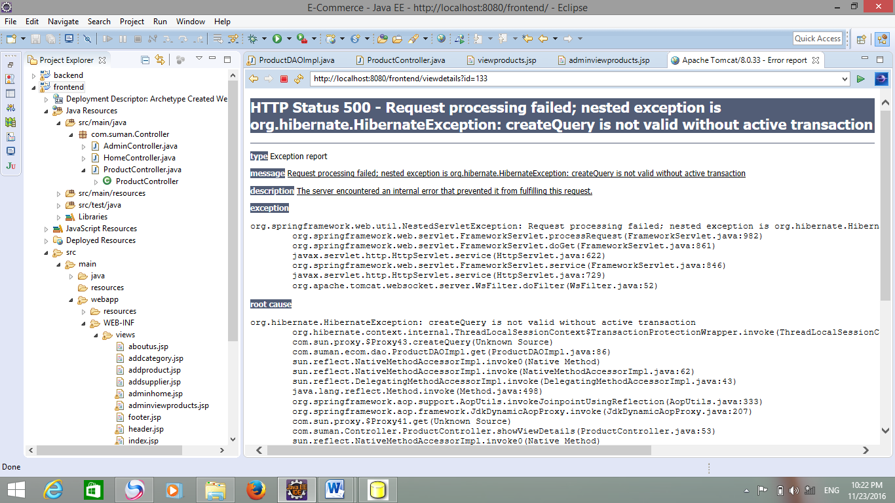

Sol; @RequestMapping(value="/viewdetails")

**public** ModelAndView showViewDetails(@RequestParam("id") String id,Model model)

{

//RequestParam is used to get values in string format

System.***out***.println("viewproduct paaaaaage");

System.***out***.println("Id:"+id);

//converting string to int

**int** i=Integer.*parseInt*(id);

model.addAttribute("productlist", productDAO.list());

Product product1=productDAO.get(i);

**return** **new** ModelAndView("viewdetails","product",product1);

}